The following is taken directly from the [ENG1060 starter guide](https://docs.google.com/document/d/1JznN_vqT83ztez4shlV4lmHPEZcXSzib0aHvLRtzIx4/edit?usp=sharing).

**Why do I need to unzip the m-files? I can open the m-files directly from the zip files.**

Yes, it is possible to open files directly from zip files. However, opening files directly from within a zip file will create its own instance/environment for that specific file. The nature of the separate instances means that files within a zip file are unable to communicate with one another. So even though you are able to open files directly from zip files, you will run into issues later in the semester when an m-file is required to call and use another m-file.

Consider the zip file below that contains 6 m-files. The attraction_template.m file will not be able to communicate with any of the other files in the zip file if opened directly. You must first unzip the files (see next section).

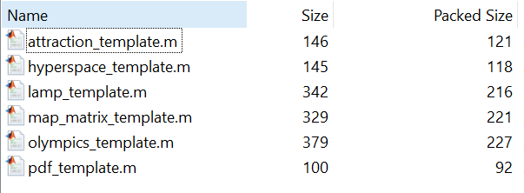

**How do I unzip files?**

1. Locate the zip file you wish to unzip/extract files out of.
2. Most operating systems have inbuilt software to compress/extract files. Download [7zip (it’s free!)](https://www.7-zip.org/download.html) and install it if you require a dedicated software.
3. After installing 7zip, right-click the zip file, go to the 7zip option and choose extract here.

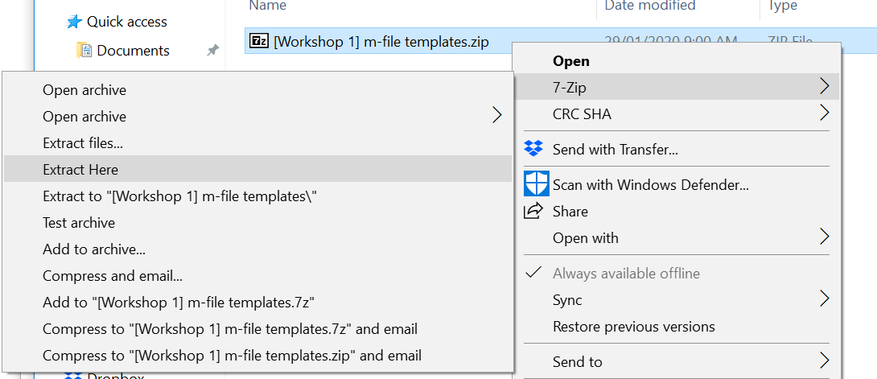

1. Your directory should now have the original zip file and also copies of the zip file contents. I.e. the contents of the zip file has been unzipped. You can now work on the unzipped files and they will belong in the same environment, allowing the files to communicate with one another.

